TGNA Monthly Newsletter: April 2026
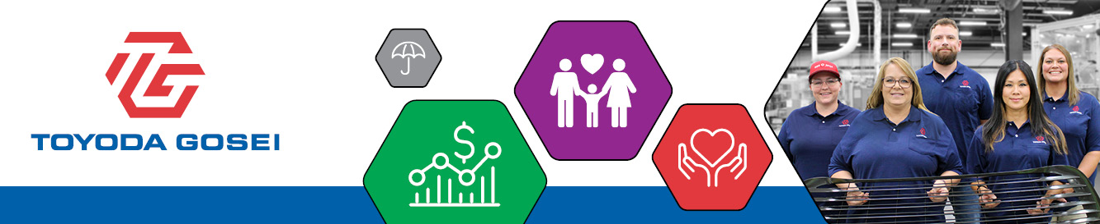
MAKE THE MOST OF YOUR BENEFITS ALL YEAR LONG
From paying for health care expenses to saving for retirement, your TG benefits offer more value than you might realize. This month, learn how Health Savings Accounts and Flexible Spending Accounts can support your health and your wallet.

Your HSA: Spend, Save or Stay Flexible
If you’re enrolled in the Optimal medical plan and have a Health Savings Account (HSA), you can use your HSA to pay for eligible health expenses during the year.
HSA funds can cover more than just deductibles and prescriptions, they can also be used for dental and vision care (including braces, glasses, and contacts), mental health services, chiropractic care, acupuncture, first aid supplies, and at‑home medical tests.
Did You Know?
- Any money you don’t use stays in your account and rolls over year-to-year. While HSAs are great for current expenses, they can also help you prepare for future healthcare costs, including those in retirement.
- You can contribute to your HSA on a pre-tax basis, up to the 2026 annual IRS limits below, and you can stop, start or change your contribution at any time during the year through bswift, our benefits administration platform.
  - Employee-only medical coverage: $4,400
  - All other coverage levels: $8,750
  - Catch-up contribution (if you’re over age 55): $1,000
- Every pay period, TG contributes, too!
  - Employee-only Coverage: $25 per-pay-period, up to $650 per year
  - All other coverage levels: $50 per-pay-period, up to $1,300 per year
- Once your account balance reaches a minimum balance, you can start an investment account.
Visit livelyme.com or call 888-576-4837 for more information or to check your balance.
Spend Smart: How to Use Your FSA
If you contribute to a Flexible Spending Account (FSA), remember it’s a “use-it-or-lose-it” benefit. That means any money left in your account at the end of 2026 is forfeited, so be sure to spend your funds throughout the year! Log in to livelyme.com or call 888-576-4837 to review your FSA balance(s) or submit a claim for reimbursement.

Health Care FSA
The Health Care FSA can be used for many out‑of‑pocket medical, dental, and vision expenses, including deductibles, copays, glasses and contacts, orthodontia, and other dental care. It also covers services like chiropractic care and acupuncture, as well as eligible over‑the‑counter items such as heating pads, ice packs, and even sunscreen (SPF 15+). NOTE: If you contribute to an HSA, you cannot participate in the Health Care FSA, you are instead eligible for the Limited-Purpose FSA.

Limited-Purpose FSA
The Limited-Purpose FSA can be used for eligible dental and vision expenses only, until your medical plan deductible has been reached. Think exams, cleanings, fillings, braces, glasses, contact lenses, and even LASIK. If you have upcoming appointments or need to stock up on supplies, your FSA can help cover those costs.

Dependent Care FSA
You can use your Dependent Care FSA to pay for child or eldercare expenses that allow you to work or attend school full time. Eligible expenses include daycare for children under 13, preschool, before/after-school care, summer day camps, and elder care for dependents who are incapable of self-care.

Don’t Forget About the Lifestyle Spending Account (LSA)!
The LSA is a flexible and inclusive wellness program that is designed to support your health by providing money you can spend toward personal, everyday wellness needs. The LSA is funded by TG and is available to all team members, regardless of whether you’re enrolled in our medical plans.
Use your LSA to pay for things like:
- Gym memberships & Fitness Classes
- Fitness Accessories
- Digital Health Apps
- Financial Wellbeing Services
- and More!
Log in to livelyme.com or call 888-576-4837 to review your balance or submit a claim for reimbursement.

Want More Details About Your TG Benefits?
Be sure to visit our benefits website, tggroupbenefits.com
(password: TGNA; location: United States).
There, you’ll find helpful information about all your benefits.

